Question 1)
To answer the next question, use the information in the table below which illustrates the multiplier process resulting from an autonomous increase in investment by $5.

 | Change in Income | Change in Consumption | Change in Savings
Assumed increase in investment | $5.00 |  | $1.25
Second round |  | $2.81
All other rounds |  | 8.44
Totals |  |  | 5.00

The marginal propensity to consume is
a) 0.5.
b) 0.9.
c) 0.75.
d) 0.8.

Question 5)

If aggregate expenditure in an economy equals 2,000 + 0.8Y and full employment real GDP equals 11,000, then this economy has
A) a recessionary gap.
b) no autonomous expenditure.
c) an expansionary gap.
d) no output gap.

Question 6)

The $787-billion stimulus package enacted by the federal government in 2009 to try to deal with the Great Recession was intended to
a) close an inflationary expenditures-gap.
b) push the aggregate expenditures schedule upward.
c) shift the aggregate expenditures schedule down.
d) bring inflation down.

Question 11)

The expenditure line in the aggregate expenditures diagram represents the
a) equilibrium condition that Y = Y*.
b) relationship between consumption and after-tax disposable income.
c) relationship between expenditure and output.
d) equilibrium condition that Y = AE.

Question 16)

Which of the following factors does not explain the inverse relationship between the price level and the total demand for output?
a) a real-balances effect
b) an interest-rate effect
c) a substitution effect
d) a foreign-purchases effect

Question 26)

Use the following graph to answer the next question.
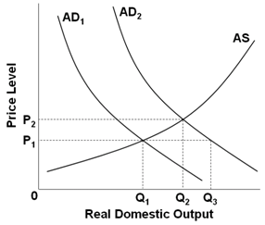
A shift from AD₂ shifts to AD₁ would be consistent with what economic event in U.S. history?
a) demand-pull inflation in the late 1960s
b) World War II in the 1940s
c) Great Recession of 2007-2009
d) cost-push inflation in the mid-1970s

Question 27)

Use the following diagrams for the U.S. economy to answer the next question.

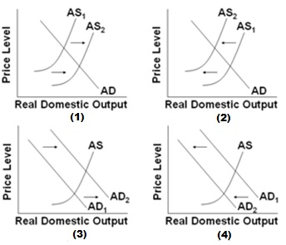

Which of the diagrams best portrays an expansion?
a) Graphs (1) and (3)
b) Graphs (1) and (2)
c) Graphs (2) and (4)
d) Graphs (3) and (4)

Question 29)

When changes in taxes and government purchases occur in the economy without explicit action by Congress, such changes are referred to as
a) discretionary fiscal policy.
b) cyclical stabilization.
c) automatic stabilizers.
d) implicit stabilization.

Question 30)

Smoothing the peaks and troughs of the business cycle with fiscal policy is
a) difficult, because economists have not developed any theoretical models of the macroeconomy.
b) relatively simple, because the political process usually works smoothly and without significant lags.
c) relatively simple, because the government has access to the best information available.
d) difficult, because the government lacks important information about the economy.
Question 31)

Which combination of fiscal policy actions would most likely offset each other?
a) a decrease in government purchases, but no change in taxes
b) an increase in taxes, but no change in government purchases
c) a decrease in taxes and an increase in government purchases
d) an increase in taxes and an increase in government purchases

Question 33)

The economy is in a recession. The government enacts a policy to increase purchases by $2 billion. The MPC is 0.8. What would be the full increase in real GDP from the change in government purchases at a given price level?

a) $8 billion
b) $10 billion
c) $6 billion
d) $16 billion

Question 34)

Assume that the full-employment level of output is $600 and the price level associated with full-employment output is 100. Also assume that the economy's current level of output is $550 and, at the price level of 100, current aggregate demand is $450. If the government wants to move the economy back to the full-employment level of output and the MPC is 0.9, then it should

a) increase government purchases by $5.
b) increase government purchases by $50.
c) increase government purchases by $15.
d) increase government purchases by $150.

